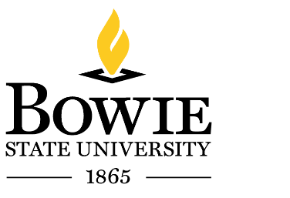
Office of Human Resources
C. Robinson Hall
T: (301) 860-3450 F: (301) 860-3453

Office of Human Resources

MEMORANDUM

To: New Employees of Bowie State University
From: Sheila Hobson, Senior Director of Human Resources
Date: _________________________
Subject: Substance Abuse Policy

I, __________________________________________________, acknowledge receipt of the Bowie State Drug Free Workplace Policy.

________________________________________ _________________________
Employee Signature Date

