Bowie State University Police Department
General Order
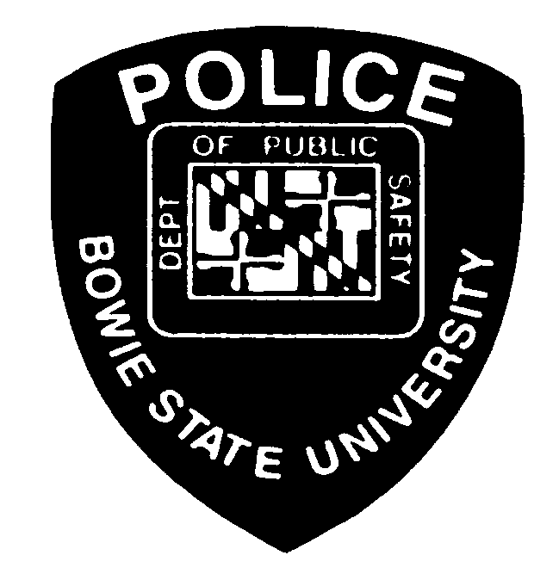
Subject : KNOWLEDGE OF THE MANUAL | Supplement 10B
Effective Date: July, 2003 | Rescinds:
Approved: Acting Director Roderick C. Pullen
CALEA Standards:

This supplement contains the policy and procedure for administering and assessing a Police Officer’s knowledge of the BSU Police Manual.

PURPOSE: To ensure that all BSU Police Personnel can identify and delineate procedures, protocols and policies contained in the BSU Police Manual.

APPLICATION: All BSU Police Personnel's questionnaires will be placed in each person's work and education file for verification of knowledge of updates contained in the Police Manual.

PROCEDURE: Each quarter there will be an assessment on the BSU Police Manual conducted by the Administrative Lieutenant for all non-exempt police officers. Each assessment will be answered and returned to the Administrative Lieutenant. All inquiries of the assessment will be submitted on the personal comment sheet provided. The Administrative Lieutenant will review and score each assessment before submitting to the Chief or Director. A minimum score of 70% is required to be considered as satisfactory.

EXCEPTIONS: None.

COMMENTS: Comments and solutions should be submitted on the comment sheet provided with each assessment.

SOLUTIONS: Each member will be given a copy of their assessment along with a copy of the answer sheet according to the BSU Police Manual for any and all corrections. Upon completion of the assessment, a review will be done by the Administrative Office.

