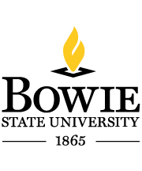
Bowie State University Staff Council

2015-2016 Bowie State University
Staff Council Meeting Schedule

2015

Thursday, July 9, 2015
Thursday, August 13, 2015
Thursday, September 10, 2015
Thursday, October 8, 2015
Thursday, November 12, 2015
*Thursday, December 10, 2015

2016

Thursday, January 14, 2016
Thursday, February 11, 2016
Thursday, March 10, 2016
Thursday, April 14, 2016
Thursday, May 12, 2016

All meetings, with the possible exception of the December 10, 2015 meeting will be held in the Special Collections room of the Thurgood Marshall Library. The meetings will begin at 10 am and end at 12 noon.

*Annual Christmas Party. Location to be announced

