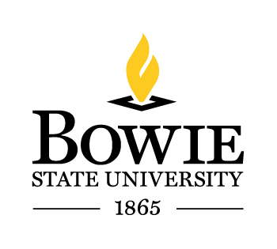 | OFFICE OF HUMAN RESOURCES  POSITION ANNOUNCEMENT

POSITION TITLE Development Specialist

PERSONNEL STATUS: PIN/Exempt

DEPARTMENT: Institutional Advancement

OPEN DATE: September 12, 2014

CLOSING DATE: September 26, 2014

Responsibilities: Provides staffing for the Office of Institutional Advancement (OIA) activities involving the Board of Visitors, foundations, corporations, and individual donors; implements and maintains systems for prospect research, cultivation, solicitation, and stewardship; formats proposals, foundation grant reports, presentations and other materials intended for OIA audiences; acquires knowledge of Bowie State University’s history and strategic plan tasks related to resources and outreach.

Qualifications: Bachelors degree required. Minimum one (1) year professional experience with nonprofit organizations and/or resource development including foundations, corporations, and individual fundraising required. Strong written and verbal communication skills; demonstrated ability to multi-task and work in a fast paced environment; attention to detail, accuracy, and good judgment; must have the ability to travel periodically.

Condition of Employment: This position is Title III grant-funded. Employment is subject to available funding.

SALARY: $53,000 - $62,000 Range: I

APPLICATION: Interested and qualified applicants should submit two copies of a cover letter, resume/curriculum vitae, BSU Employment Application, along with a list of at least three (3) professional employment references. Submissions without an application will not be considered. Email or mail all documents to:

Office of Human Resources
Bowie State University
14000 Jericho Park Road
Bowie, MD 20715
JOBS@bowiestate.edu

Bowie State University is an Equal Opportunity/Affirmative Action Employer
Auxiliary aids and services for individuals with disabilities are available upon request. Please contact the University’s EEO Officer at 301-860-3442.

To download the BSU application, go to http://www.bowiestate.edu/files/resources/staff-employment-application.pdf

In accordance with the Cleary Act of 2000, you are advised to contact the Bowie State University Campus Police Office for Disclosure of Criminal Incidents that occur on our campus.

