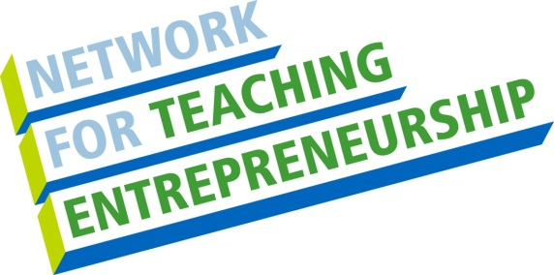 NFTE Summer BizCamp®

The Network for Teaching Entrepreneurship (NFTE, pronounced “nifty”) is offering a summer camp to students (ages 14-18) on the Campus of Bowie State University, School of Business.
If you answer YES to any of the following questions…we are looking for YOU!!!
Have you ever thought of starting your own business?
Do you have a business already?
Are you interested in learning how your hobby can make you money?
Do you want to be your own boss?
Do you want to win awards and earn money?

Become an ENTREPRENEUR! Join NFTE’s Summer BizCamp® TODAY!

NFTE BizCamp®: (July 7 – July 18, 2014)
BizCamp® is a two-week intensive summer program, including field trips and guest speakers, aimed at providing students with a solid business background. At the end of the class, students will compete for cash awards to fund their businesses.
Application Deadline: (June 13, 2014)
For an application, please contact:
Verice White
202-467-6383

