**Ad**

**President**

Dr. Mickey Burnim

***Prepare for Life***

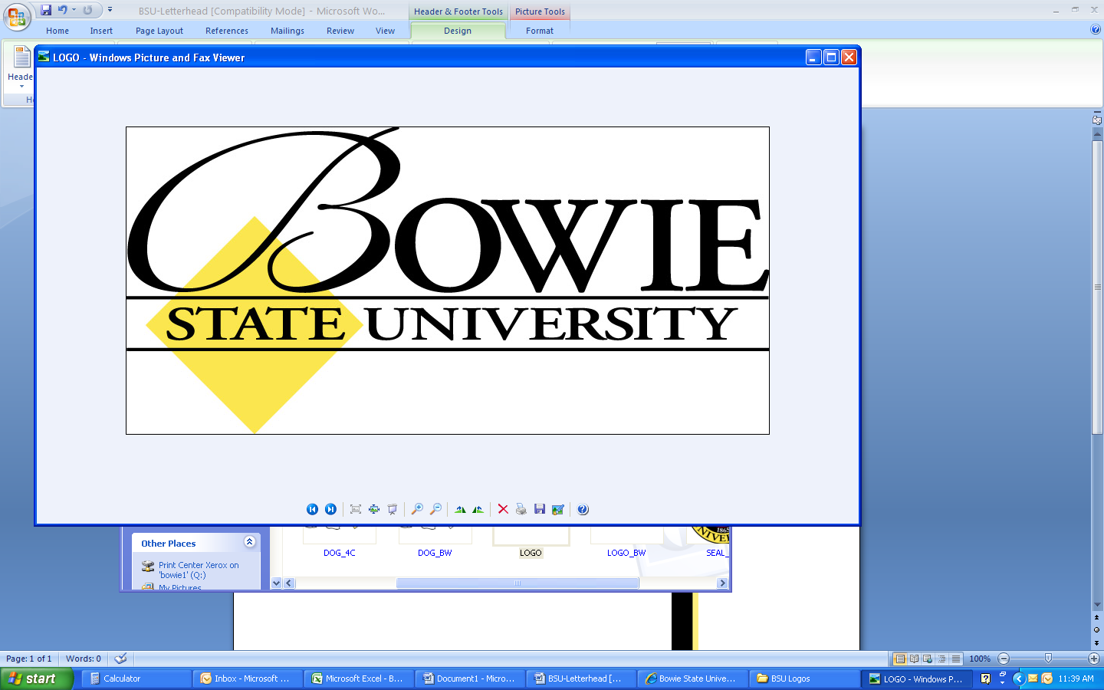

(Vacant)

**Provost**

Dr. Weldon Jackson

**Dean**

Dr. Anthony Nelson

**College of Business**

**Organizational Chart**

**FY 2013-2014**

**Staff Assistant**

Gwenda Clark

**Board of Advisors**

**Admin Assistant** Deborah Adams

**Student Advisory Council**

**Graduate Student Advisory Council**

**Coordinator of Assessment**

**and Accreditation**

Nedra Mahone

**Bowie Business Innovation Center**

**Coordinator: Acct**

- Prof. Joe Lanciano

**Coordinator: Fin**

- Dr. Sunando Sengupta

**Coordinator: Econ**

- Dr. Regina Tawah

**Chair: Mgt, Mktg, PA**

Dr. Stevie Watson

**Retention Coordinator**

Nichole Mason

**Coordinator: MS MIS**

Dr. Bin Mai

**Admin Assistant**

Iyonne Heard

**Admin Assistant**

Frances Thorn

**Admin Assistant**

Gloria Bethea

**Chair: Mgt Info Sys**

Dr. David Anyiwo

**Chair: Acct, Econ, Fin**

Prof. Samuel Duah

**MBA Coordinator**

Dr. Granville Sawyer

**Coordinator: Mgt**

- Prof. Richard Lowery

**Coordinator: Mktg**

**-** Dr. Ella Carter **Coordinator: MPA**

- Dr. Kevin Glasper