Office of Human Resources
PeopleAdmin Training Guide

Table of Contents

Introduction 3
Login Information 4
Home Page Screen 5
Home Page Features 6
Core Functions of Applicant Tracking System 7
Creating a New Posting 8
Posting Workflow 16
Reviewing Applicants 17

Introduction
Welcome to the Bowie State University PeopleAdmin Employment Applicant Tracking System! The Office of Human Resources is actively using PeopleAdmin to automate a lot of the paperwork required during the application process.

You will use this system to:
- Create and submit job postings
- Screen applicants
- Review applicants

PeopleAdmin has several benefits to include:
- Faster processing of employment information utilizing less paper.
- Real time access to information regarding job postings.
- More detailed screening of the applicants’ qualifications before they get to the interview stage.

Login Information
- Website address: https://bowiestate.peopleadmin.com/hr/login
- You will login with your current network login information. New users please contact Human Resources to be approved and added to the system.
- If you have forgotten your password, you can also reset it by clicking on Request a Password Reset.
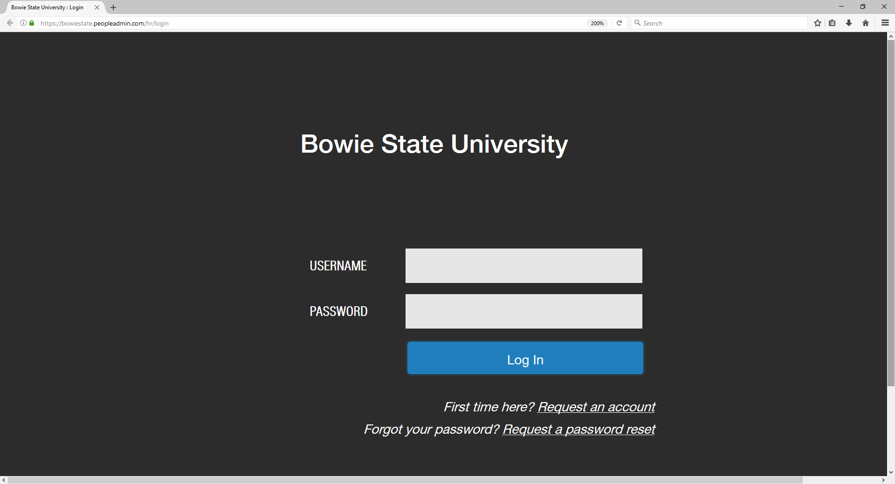

Home Page Screen

Once you have logged into PeopleAdmin, select your Current Group from which you apply from the drop down box. Once selected, your Home Page will display an inbox, watch list, and other items that enable you to easily navigate through actions which need your attention.

- Inbox
A notification area where the system will display any actionable items.
- Watch List
Tracks items that are in the posting process. It is highly recommended to add any postings to the watch list.
- Shortcuts
Shows certain shortcuts based on user permissions.
- My Links
Useful resources, such as training videos and customer support.

Home Page Features

Current Group (User Group)
Allows you to select the user group you want to work from. Everyone will have the “Employee” and “Search Committee” options. Groups could include the following positions:

- Hiring Manager/Initiator: Initiates a new position action. Reviews applicants for posting.
- Level 2 Approver: Generally the Department Head. Can initiate a new position action or modify position description action. Approves actions sent from the Hiring Manager/ Initiator user group.
- Area Vice President: Approves actions sent from the Level 2 Approver user group.
- Grants Compliance: Makes sure grant-funded positions meet eligibiity requirements for the grant.
- Grants Accounting: Approves funding for grant-funded positions.
- Budget: Reviews and approves all state-funded positions.
- Vice President of Administration and Finance: Reviews and approves all state position actions.
- President: Reviews and approves all position actions.
- Senior Director of Human Resources: Reviews and approves all position actions.
- Search Committee Member: Invited by Hiring Manager/ Intitiator to participate in review of candidates and/or interviews.

Applicant Tracking

Used to create postings and review applicants.

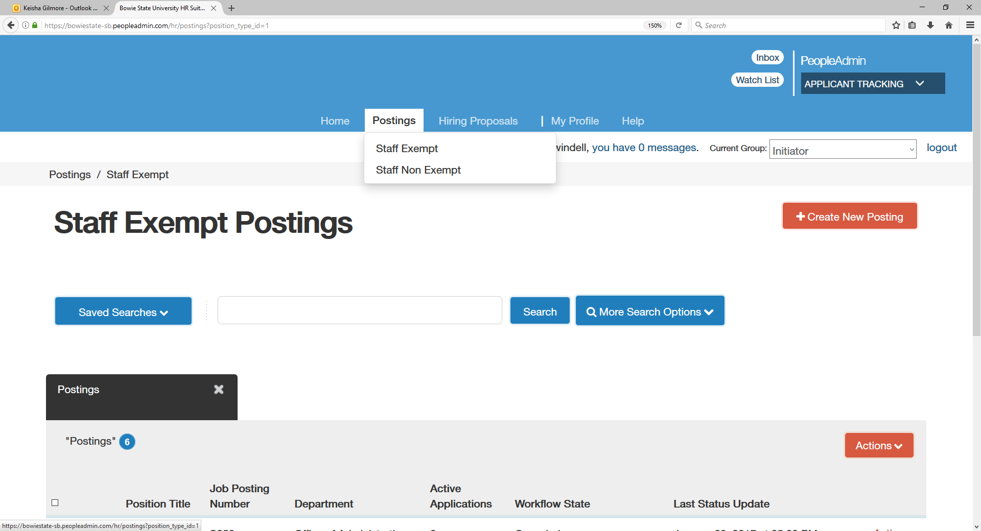

Core Functions of the Applicant Tracking System:

- Posting, monitoring, and taking action on job postings, requests to post, and other employment-related tasks.
Creating a New Posting
- Click on the drop down arrow next to Current Group in the upper right corner and select your user group, i.e. Initiator, Level 2 Approver, Vice President, President.

- Select the appropriate User Group that applies
- Click on the Postings tab at the top of the screen.

- Click the appropriate position type: Staff Exempt or Staff Non Exempt.
- Click on the Create New Posting button.

- After you click, there will be 2 options to choose from:

  - Create from Position Type- This selection allows you to create a posting from scratch using a blank screen. If the position you are posting is not already in the system, you will need to select this option.
  - Create from Titles- This selection allows you to create a posting from an existing template.

- Select Create from Titles. There will be a list of Staff Exempt and Non Exempt templates to pick from. 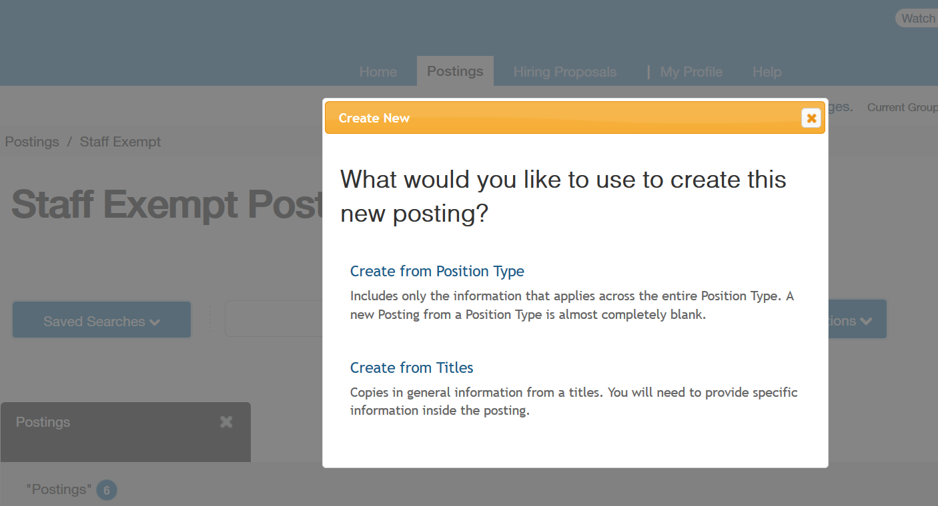

- Click on the appropriate Position Title from the list.

- Review the Job Posting Template.

- Select Create Posting from This Title.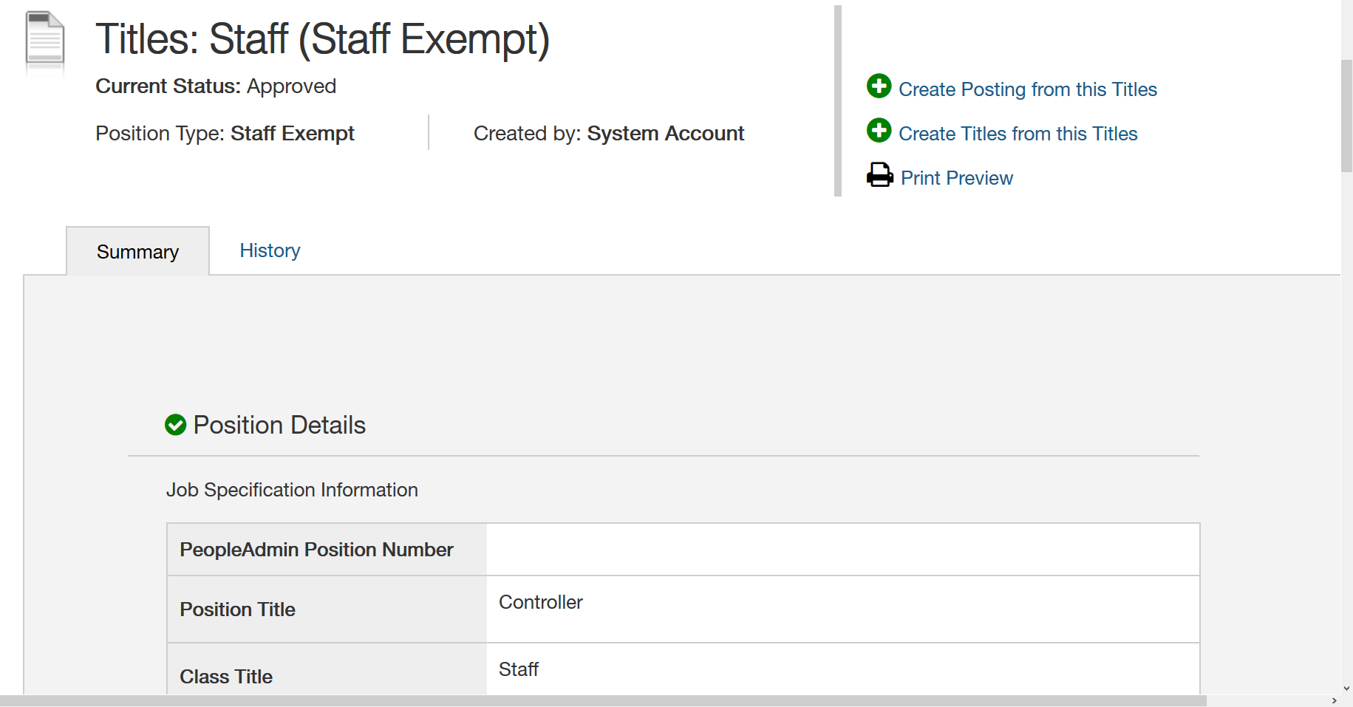

- Update/complete required information.

- Select Create New Posting.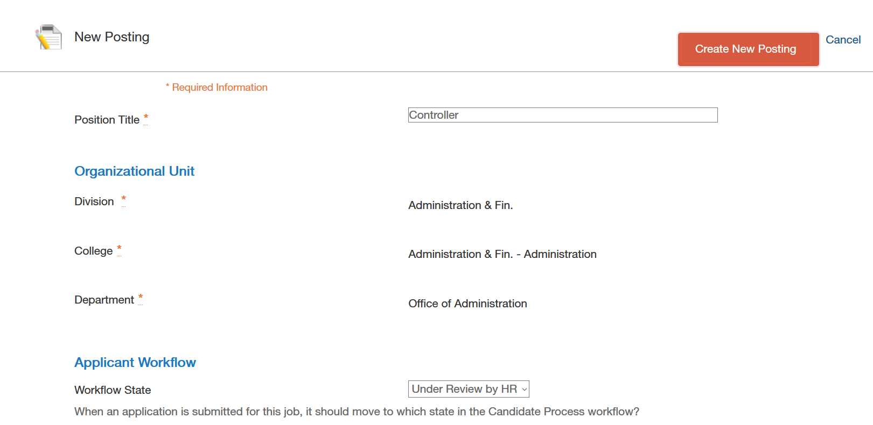

- Update the posting with any changes or additions.

- The Editing Posting pane on the left hand side indicates the areas that will come up as you go through the posting.
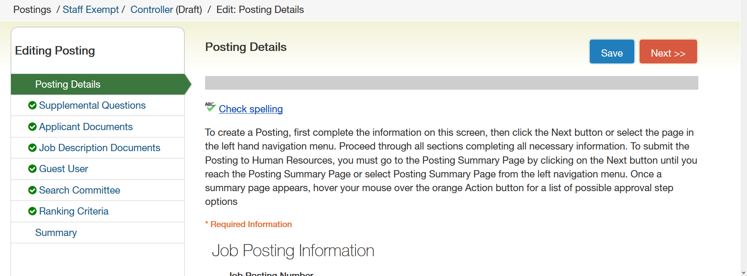
- Click Next after entering all information.

- The Supplemental Questions are questions that can be added for applicants to respond to relative to the job requirements. There is a bank of previously used supplemental questions or you can create new questions. If creating a new question, it will first have to be approved by Human Resources before being added.
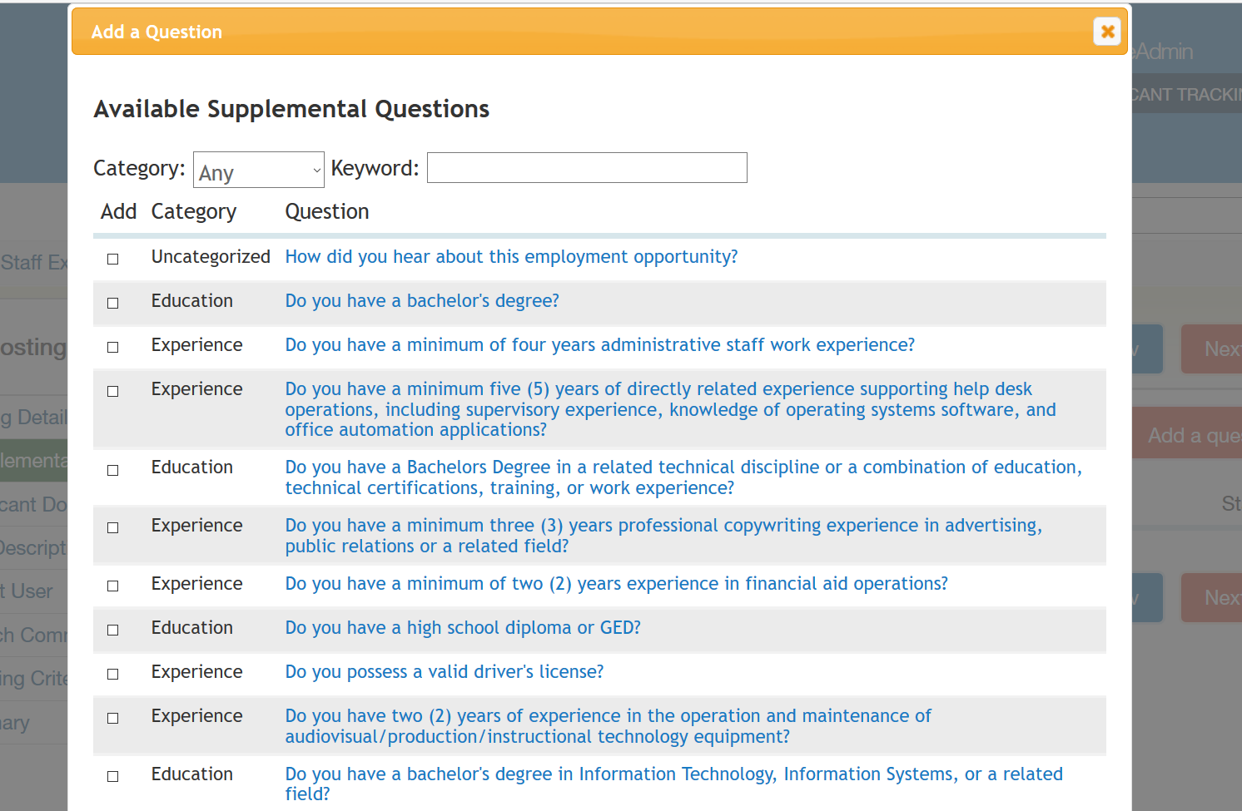

- Once a question is added, click on the Blue Question Link to specify if you want the answer choice to be disqualifying.
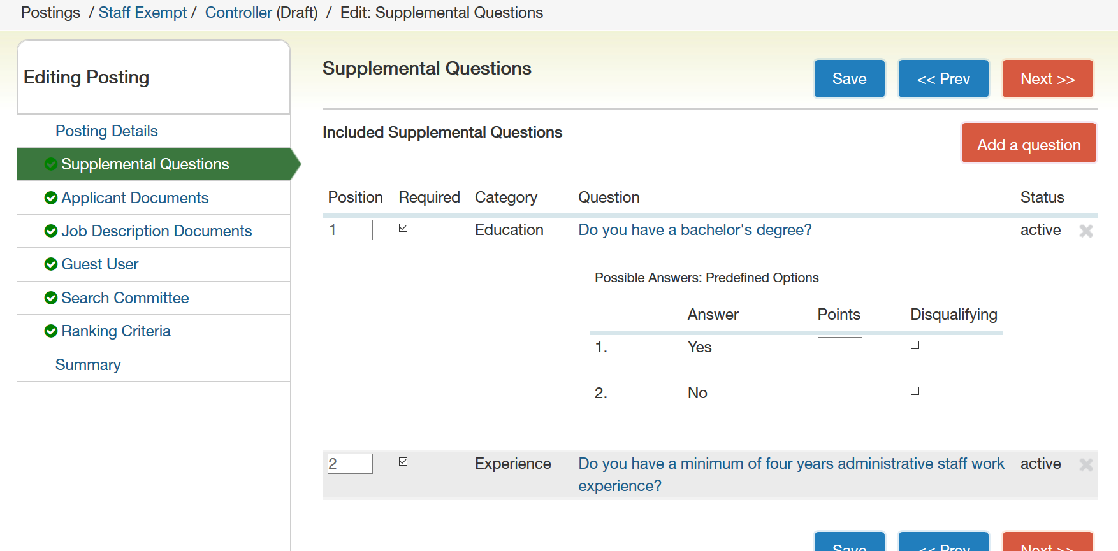
- Click Next to go to the following page.

- Applicant Documents: Choose which documents the applicant should include in the application from this list.
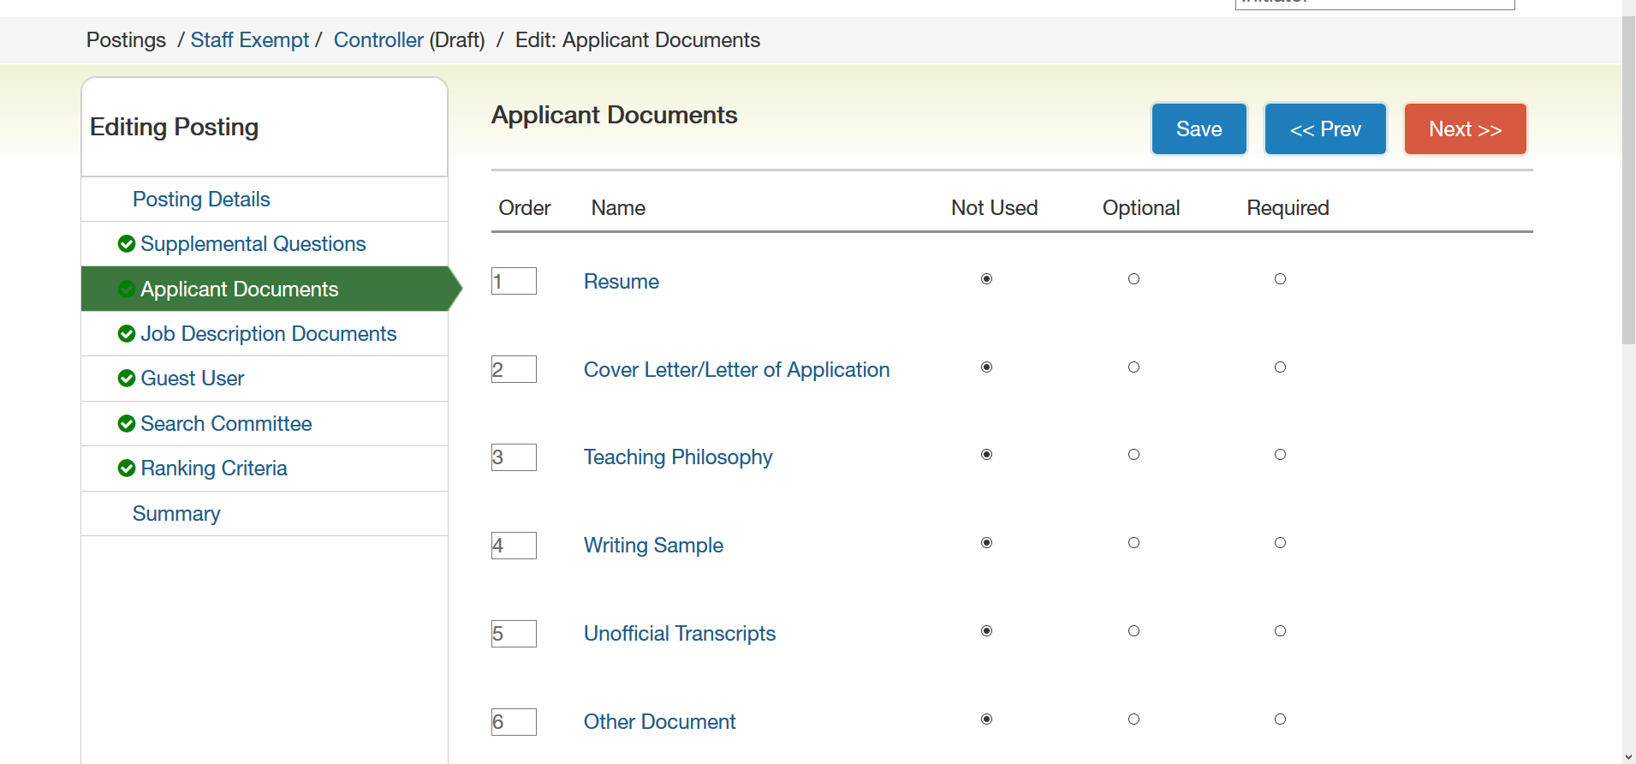

- Job Description Documents: Allows you to attach additional documents to the posting for consideration during the approval process.
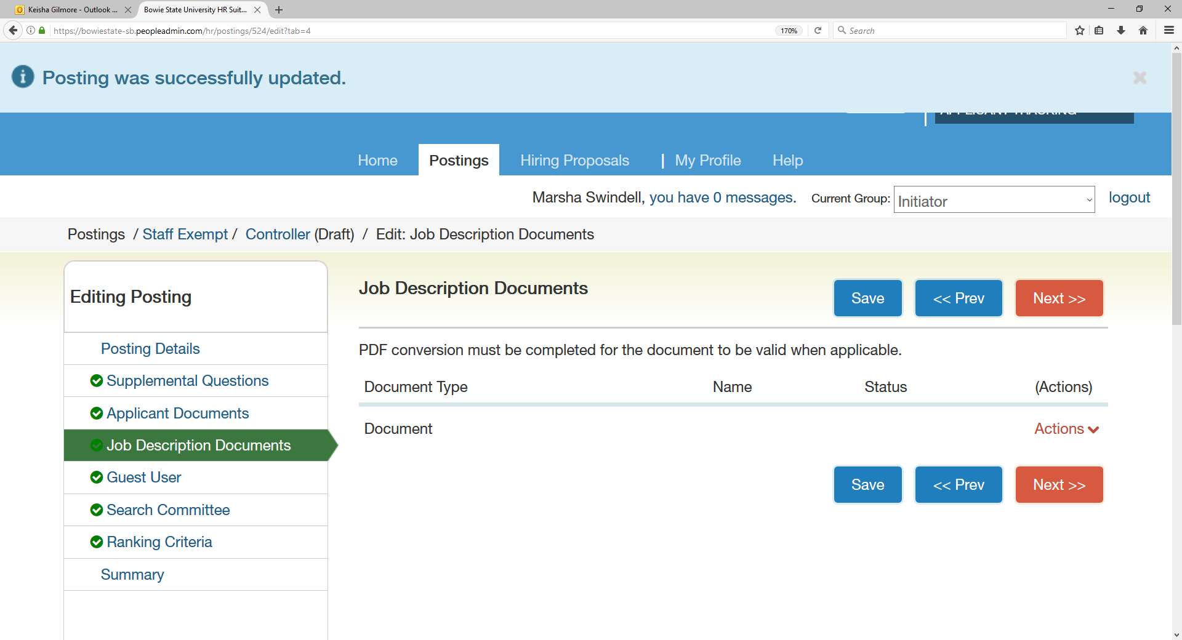

- Guest User: If you have someone from outside of the University that you want to serve on the Search Committee, enter their information here.
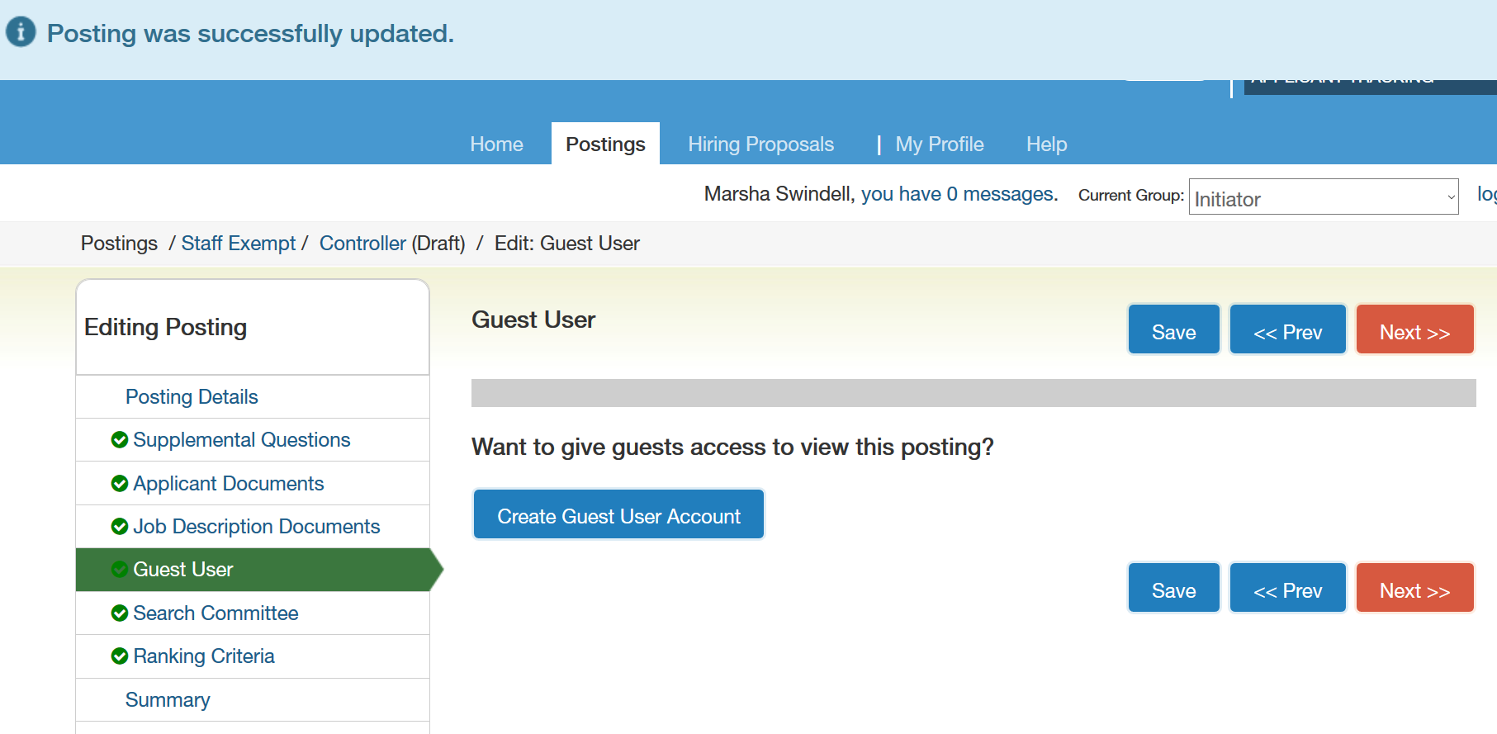

- Search Committee: You can assign members to the search committee here. You can also search for existing search committee members using the Add Existing User or Create New User Account.
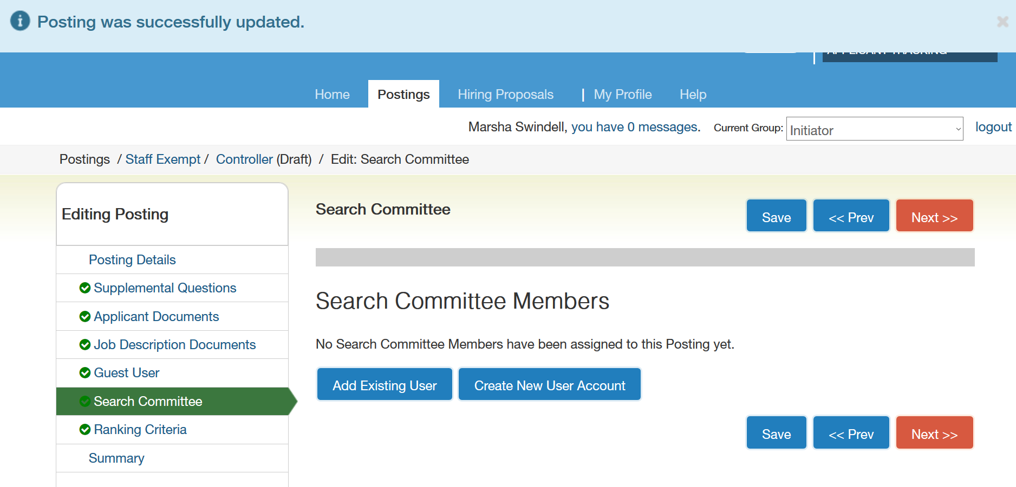

- Ranking Criteria: You can add evaluative criteria to the posting here. It can be used during the screening process to rank applicants and assign points or weights to certain questions. Click on Add a Criterion button and you will have the ability to add criterion or select an existing criterion.

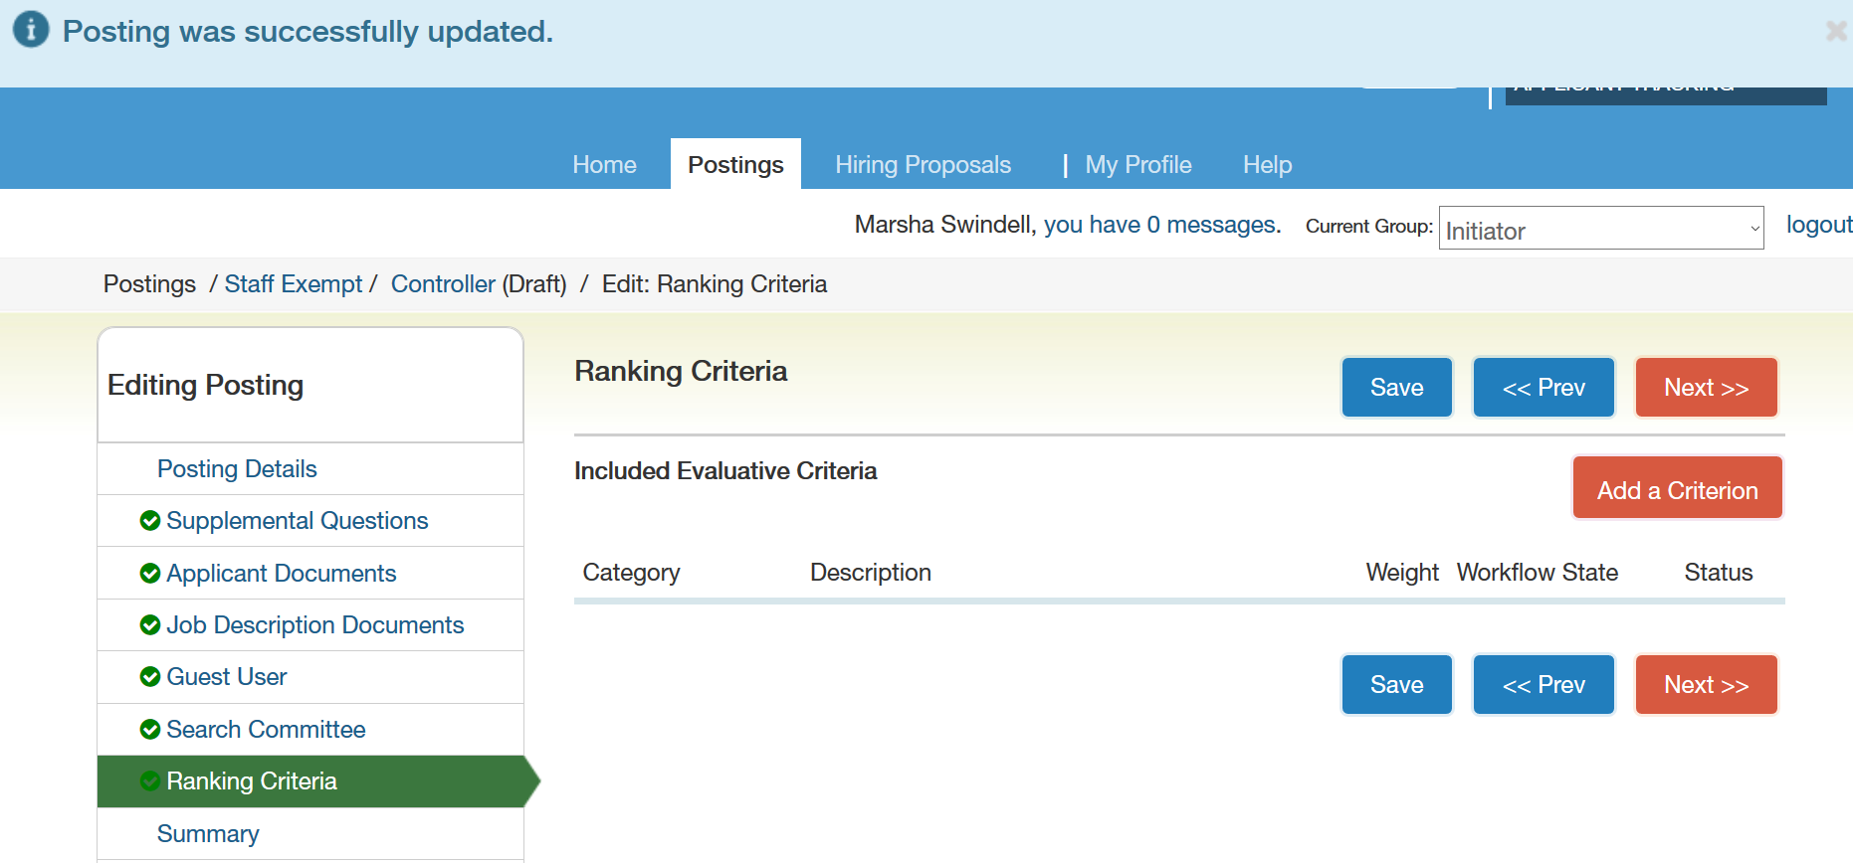

- Summary Page: Here, you can review the posting, see how it looks to applicants, and see the print preview of the posting. You can also move the posting in the workflow for approvals here.

- To move the posting along in the workflow, hover over the Take Action on Posting button and select the action you would like to take.
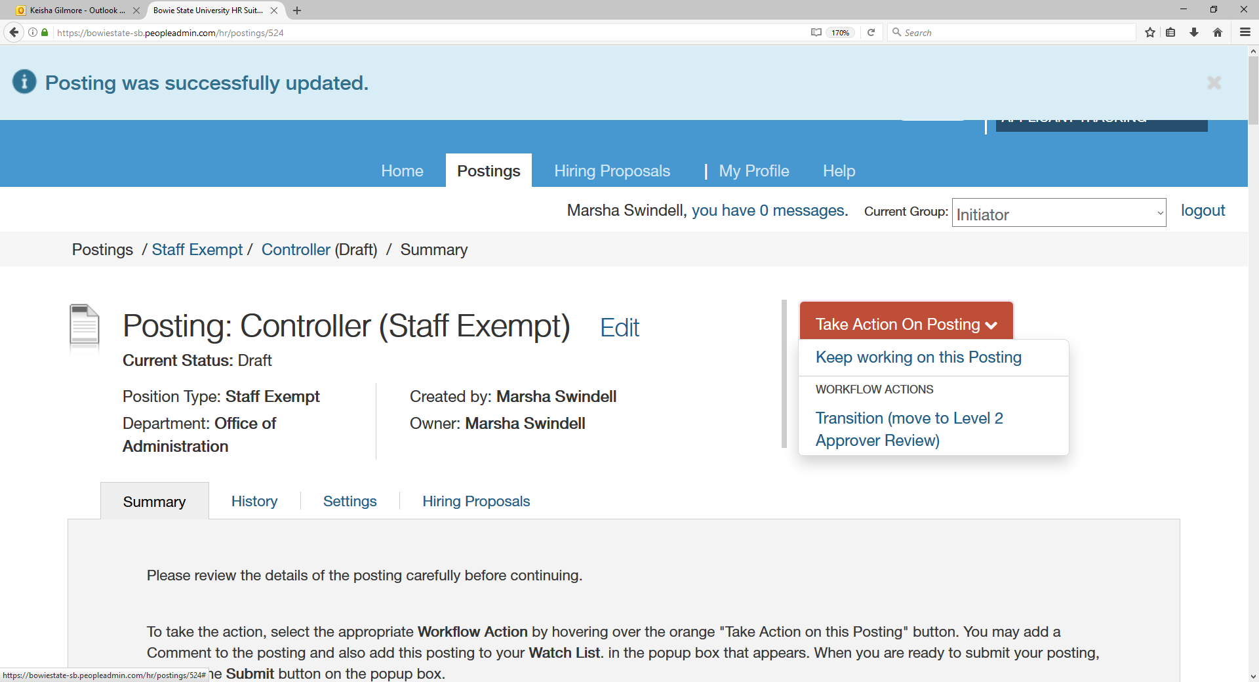

- While transitioning during the posting, you will have the opportunity to add a comment, which will appear in the requisition’s history. You can also flag the posting on your watch list and this will display the requisition in the watch list of your home screen to monitor.

How Does a Posting Move in the Workflow?

Staff Exempt and Non Exempt Requisitions/ Postings
Human Resources
VP of Admin and Finance
Initiator/
Hiring Manager
Senior Director of HR
President
Budget
VP
Level 2 Approver

Grant-Funded Staff Exempt and Non Exempt Requisitions/ Postings

Human Resources
Senior Director of HR
Grants Accounting
Grants Compliance
Level 2 Approver
Initiator/
Hiring Manager
Provost

Reviewing Applicants
- Click the Postings tab and select the appropriate position type (Staff Exempt or Staff Non Exempt).
- Click on the applicable position.

- Click on the Applicants tab above the posting details.

- Click in the first box to the left to highlight all applicants.
- To review an individual applicant, click in the box to the left of the applicant’s name.
- From here, you can click on the orange Actions button to perform a variety of tasks, such as reviewing the screening answers and downloading the application(s).
- To print the application(s), select Download Applications as PDF.

- A Dialog Box will appear asking you to select which documents you would like to include when you print out the application(s). Select your preferences.
- The system will generate the application(s) as you requested and you will be able to print like a normal PDF document.

