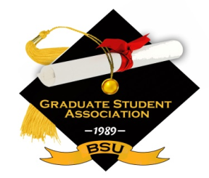

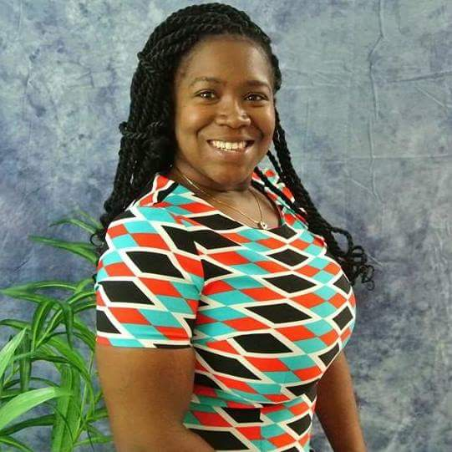

Greetings,

My name is Ramonia Morant, President of the Bowie State University Graduate Student Association. On behalf of the association and its members’ we are delighted you have chosen to pursue your graduate education at Bowie State University. As a graduate student, you are embarking on a significant transitional period, in which you will be challenged intellectually, enriched academically, and rewarded both personally and professionally.

The Graduate Student Association officers and members are ready to assist you in providing the

best educational experience possible. We look to you to make the most of your graduate studies by fully participating in the Graduate Student Association. We provide professional development, social activities, conference sponsorship, and other special events. The Graduate Student Association is liaison between the graduate students and the University and Administration.

We are your voice and we respond to the needs and concerns of all graduate students. We strive to improve the quality and experience of the graduate program at Bowie State University. I confident your choice in Bowie State University will be a rewarding experience. I look forward to meeting and working with all of you.

If there is anything we can assist you with during your matriculation at Bowie State University, please feel free to contact me.

# History of the GSA

By Dr. Cubie Bragg

The Graduate Student Association (GSA) was founded during the 1989-1990 school year   
by a small group of concerned graduate students. This group distributed a survey to all graduate  
students at Bowie State University and learned that, although graduate students make up ten percent of Bowie's student population, their needs and concerns were not being addressed. Therefore, in the fall of 2003, with Dr. Cubie A. Bragg as advisor and Michael Hester as president, the Graduate Student Association was officially formed.

In the fall of 2007, GSA worked towards establishing its identity by developing both a logo and a motto. The GSA motto of "*Empowering Leaders, Continuing Excellence*" was approved in September of that year. This represented a milestone, as GSA is the first campus based association to ever receive this approval.

In the spring of 2009, under the leadership of President Kelechi C. Anyanwu, GSA revised its Constitution and Bylaws and adopted new amendments which became the standards by which GSA is governed. In the spring of 2010, after additional revisions were made by the Vice President of Student Affairs, the Interim Dean of the Graduate School and the Faculty Advisor, the constitution was approved and became the official working document of the GSA. Today, GSA represents ten graduate organizations and over 1,200 graduate students. GSA provides networking opportunities for graduate students at BSU through such activities as event co-sponsorship, individual and group conference sponsorship, and many other social and scholarly activities. represents ten graduate organizations and over 1,200 graduate students. GSA provides networking opportunities for graduate students at BSU through such activities as event co-sponsorship, individual and group conference sponsorship, and many other social and scholarly activities.

The Graduate Student Association's mission is to support all graduate students, to increase their visibility and to uphold the mission of Bowie State University. GSA also provides a vehicle for graduate students to express their needs, interests, and concerns. GSA strongly encourages graduate students to participate in social, academic, and professional pursuits.

NCE/CPCE Prep Club

By DeMarkus Taylor

This club assists with accessing resources for dedicated students pursuing a professional degree in School Counseling, Mental Health Counseling, or Counseling Psychology. NCE/CPCE prep club assists with social interactions with fellow bulldogs in developing skills and habits to pass the Comprehensive Exam and National Certified Exam. Members are introduced and assisted with the key components of the test such as Human Growth and Development, Group Counseling, Multicultural Counseling, and so forth. Some of the skills for success are reviewed; members learn time management, study skills, and stress management strategies. Join for Success!

Please see *History* on page 4

BSU Golden Legacy Newsletter

### Inside This Issue

Message from the President 1

History of the Graduate Student Association 1

Strengths That Lie Within You 2

Student Spotlight 2

Student Veterans Association 3 Student Adlerian Conference Success 3

NCE/CPCE Prep Club 4

# Message from the President

By Ramonia Morant

###### Graduate Student Organization, 14000 Jericho Road, Bowie, MD 20715

###### https://www.bowiestate.edu/about/admin-and-governance/graduate-student-association/

11/15/16

Volume 1, Issue 1

STRENGTHS THAT LIE WITHIN YOU

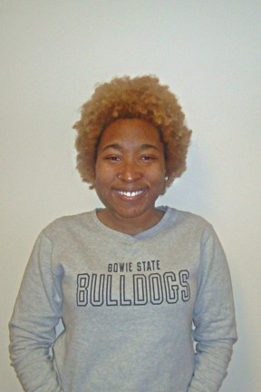

Photo: Brianna Hodge

Amina is the Director of Communications, for the Graduate Student Association

.

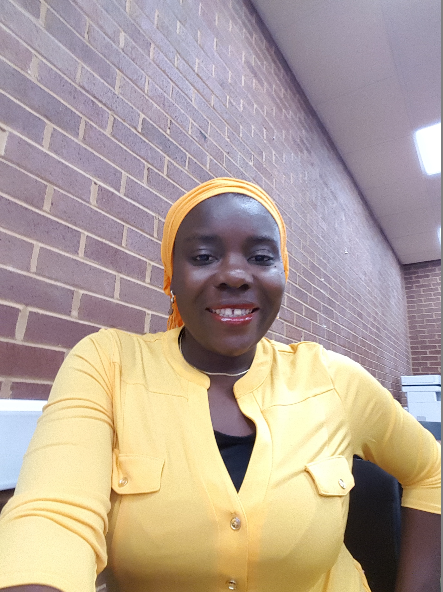

Take a breath, Take your time, Look for a minute

Look into the mirror, stare deep inside your own eyes

Call out your name, reach out for your hands

Listen for the sound of your name from your own voice

Listen for your breath, feel the inspiration take over you

Begin to look inward, and there you will unravel your strengths

The answers … O yes the answers… Lie deep within you……

By Amina Ayodeji-Ogundiran

Brianna Hodge is a School Counseling major in the College of Education at Bowie State University. She is a stellar student who takes on several responsibilities and is always finding new challenges. Brianna is an active member of the Graduate Student Association, Secretary, Chi Sigma Iota Honor Society, and a Sexual Assault Peer Educator, Partners in Peace. She devotes her time to empowering students K-12 and in higher education to utilize their talents and gifts to create new opportunities. She is currently a practicum student at an elementary school. In her spare time, she enjoys sightseeing and traveling, trying new cultural dishes, listening to music, reading, writing poetry, and playing Just Dance. She is expected to graduate May 2017 and plans to start her career as a School Counselor and work towards becoming a Licensed Professional School Counselor.

“The answers … O yes the

answers… Lie deep within you.”

By Brianna Hodge

# Student Spotlight

What does it mean to be an Adlerian Counselor? The Adlerian focus is defined in terms of a holistic perspective in accepting that all people are social beings and their actions are driven by social forces. This lesson was clearly presented by Dr. Masica Jordan, who was able to give a brief overview during the luncheon provided in the afternoon.

I was very impressed with the Conference organized by the Student Adlerian Society on Saturday, November 5, 2016. As a guest and representative for the National Alliance on Mental Illness (NAMI), I was able to learn so much information from the sessions that I participated in. The opportunities provided at this Conference were so versatile, to include topics on NCE readiness, academic risk taking, race and gender, learning therapeutic techniques, understanding relationships, understanding self, pastoral counseling, art therapy, and more!

Each presenter had their own unique qualities about themselves that added a particular essence to their presentations. I was able to actively participate in three sessions and it was wonderful to learn from Dr. Green, Dr. Bragg, Dr. Jones and Dr. Mills. I plan to integrate their teachings into my own practices for the future!

The overall conference was very well organized and the presenters and volunteers were representative of preparation and readiness. It was refreshing to be in a new environment and learn the perspectives of others throughout the day. I was so happy to have been part of this experience! Another year of excellence for SAS! Peace and blessings!

By Taylor Shiver

Student Adlerian Conference Success

The new BSU Student Veterans Association Logo

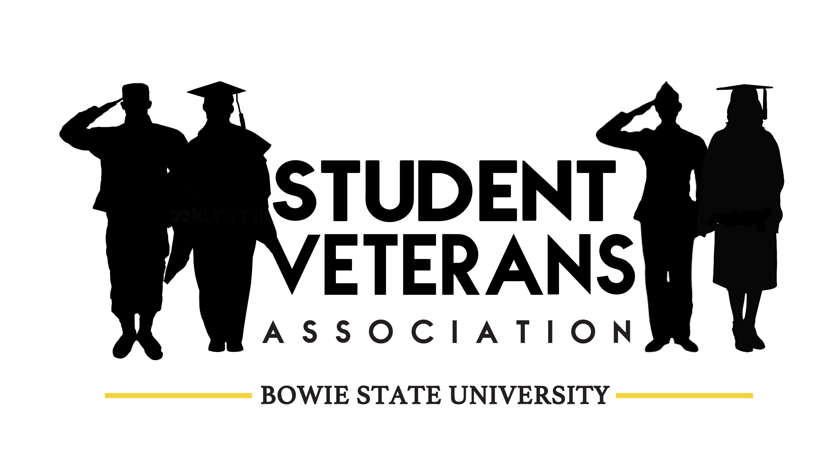

# Student Veterans Association

By Maureen Elias

One of the most difficult transitions for veterans, is the transition from military service to higher education. The beliefs and principles veterans have been taught throughout their careers; such as following orders, respecting rank, and formality, do not always gel with the independent thinking and formality of higher education. Most student veterans are nontraditional students, which may interfere with relationship building. Over half of student veterans report struggling to balance school and other responsibilities.

Student veterans may struggle with physical and emotional disabilities, many of which are invisible. Dealing with typical university physical requirements such as sitting still for long periods of time, getting to class, as well as note taking may cause them physical pain. Many veterans struggle with hearing loss or tinnitus (a ringing in the ears) which may cause them to miss conversations or have a difficult time "jumping into" classroom discussions.

Up to one third of veteran students struggle with "invisible wounds" such as PTDS, traumatic brain injury, anxiety, or major depression, which can impact their ability to concentrate or complete assignments. They may struggle with re-experiencing traumatic events, avoiding participation in class, negative thoughts or feelings, and seeming to be hyper aware of the environment. There is also a significantly high risk of suicide among student veterans.

Veterans students struggle with social isolation. Students without military experience may perceive veterans as heroic, but broken. Veterans may struggle with the perception that younger students are overly entitled and lack discipline which can create barriers between veterans and fellow students. Students may ask inappropriate questions about a veterans military service such as, "have you ever killed anyone?" Anti-military readings and or assignments as well as protests which may be held on campus can contribute to social isolation.

As you read all this, you might think, so what can I do? Become a member of the BSUSVA. Take the time to get to know the veterans and be their "civilian ally". Veterans have a lot to offer. They have very diverse perspectives, cultures, social understanding, and experiences broader than typical college-age students. They are sources of strength, vision, and leadership among higher education campuses. They are used to serving in a team, and can be great assets on the many group projects you will be assigned at BSU.

If you would like to get to know the veterans and other student supporters on campus, please join us for our meetings, the first Tuesday of each month at 4:00 p.m. in the Military Resource Center in the Library.

guests.

The SVA is working under a ew

entitled and lack discipline which can create barriers between veterans and fellow students. Students may ask inappropriate questions about a veterans military service such as, "have you ever killed anyone?" Anti-military readings and or assignments as well as protests which may be held on campus can contribute to social isolation.

As you read all this, you might think, so what can I do? Become a member of the BSUSVA. Take the time to get to know the veterans and be their "civilian ally". Veterans have a lot to offer. They have very diverse perspectives, cultures, social understanding, and experiences broader than typical college-age students. They are sources of strength, vision, and leadership among higher education campuses. They are used to serving in a team, and can be great assets on the many group projects you will be assigned at BSU.

If you would like to get to know the veterans and other student supporters on campus, please join us for our meetings, the first Tuesday of each month at 4:00 p.m. in the Military Resource Center in the Library.

***Student Veterans* from page 3**

There is also a significantly high risk of suicide among student veterans.

Veterans students struggle with social isolation. Students without military experience may perceive veterans as heroic, but broken. Veterans may struggle with the perception that younger students are overly

*History* from page 1

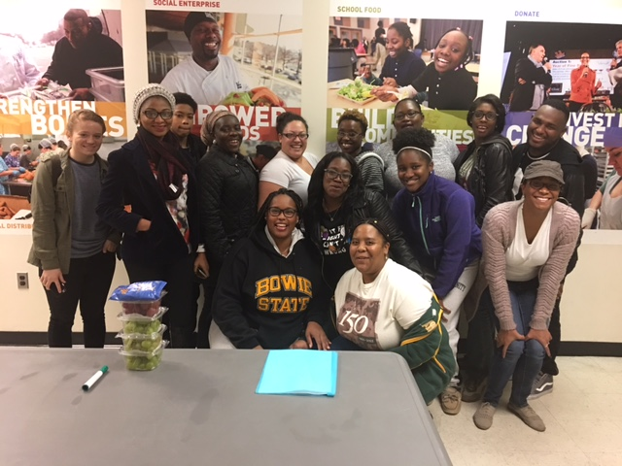

***UPCOMING EVENTS***

***Brown Sugar Poetry Jam***

***Fine and Performing Arts Center***

***Black Box Theater***

***11/18/16 6-8pm***

***Student Veterans Association***

***General Body Meeting***

***Guest Speaker Joe Cafferty-Team Rubicon***

***12/06/16 4pm***

***Suite 1126, Library***

***African Student Psychology Association***

***Kwanzaa Celebration***

***12/12/16***

***Winter Commencement***

***A.C. Jordan Arena, Leonidas S. James Physical Education Complex***

***12/16/16 10 am***

***Processional begins at 9:40am***

Students volunteered at the DC Central Kitchen

*The best way to find yourself, is to lose yourself in the service of others*